Bethanie Isaac
Professor Kimball
ENC 1101-28
30 July 2014
Essay #3: Revisions

Global Issues:
- I made the points in my introduction more clearly to my audience.
- I gave more information on the stories that were included in my op-ed.
Local Issues
- I came up with a title for my essay
- I made corrections to punctuations.

Bethanie Isaac
Professor Kimball
ENC 1101-28
29 July 2014
Cinderella Feet
In the early days, I was a big believer in cosmetic surgery. I even thought of becoming a plastic surgeon as a little girl. If a nose job will make a women feel better about her appearance, then so be it. That nose job could have been her stepping-stone away from depression and into a life full of confidence. Let’s meet Farrah Abraham. After giving birth to her little girl, Farrah was depressed and embarrassed of her body, especially her breasts. Due to the birth, Farrah believed that her breasts “shrunk” as well as “sagged”. Through observation, she was aware that her young daughter fed off her demeanor and quickly took action. After consulting with several doctors, Farrah received breast augmentation. Not only is Farrah’s confidence skyrocketing, but her daughter is also surrounded by positivity. When mom is happy, so is the baby. In relation to stories like this, I truly believed that cosmetic surgery, in a reasonable sense, was a gift to women to feel more comfortable in their skin.
Now, in today’s age, we have a wide range of cosmetic procedures. We have the basics such as liposuction, facelifts, botox injections, and breast implants. These are FDA approved and what I consider to be reasonable. A little nip and tuck in these areas are considered harmless due to advanced technology. Lets move forward to the year 2014 and my belief in cosmetic surgery is at an all time low. From butt implants to the “vampire” face-lift, we have evolved into such nonsense. Most of the new cosmetic surgeries that are surfacing are not FDA approved or scientifically proven to even guarantee the results you’re looking for. I didn’t even mention the side effects and these procedures are rapidly growing in demand. Risks include infection, wound opening, loss of feeling, and extrusion. Will that stop most of these women? NO! As long as these procedures are brought up, women will continue to fall for these fads.
Don’t get me wrong; I was an advocate for most cosmetic procedures. You want to get rid of wrinkles, go ahead and freeze your face. Want bigger breasts? Feel free to have water balloons inserted inside. I had no problem with the world of cosmetics and how they took care of business. That was until I read this headline:

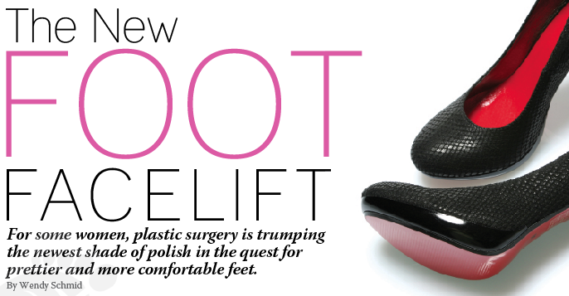
Crazy huh? Upon researching this technique, you’ll be surprised on the amount of women want this procedure done. In the past few years, news outlets have reported that dangerous procedures, such as the foot facelift, are becoming more popular with women who are self-conscious about their feet. The foot facelift differs from these other types of surgery due to the simple fact that not too many doctors agree on operating on such shallow reasons. If not needed, the chances of a botched job are extremely high. Dr. Ali Sadrieh claims he is overwhelmed with requests from women seeking cosmetic surgery on their feet. “A lot of women are embarrassed by their feet, they want them to look better in sandals, to fit into designer shoes, or just to be more comfortable,” he says. Sadrieh estimates that he turns away about 40% of patients because their perceived flaws are too theoretical. Before I get ahead of myself, lets get to know this new trend.
The foot facelift involves surgical procedures from shortening or lengthening the toes to shaving off bunions and slimming the feet. It is also performed to make feet narrower and to "enhance the appearance.” Some of these popular procedures seem quite extreme, but some have been around for a while. Before it popularly became known as the foot facelift, this procedure was actually done for those in need. Lets take Roxanne Marks story for example. Thanks to bunions and a painful pinky toe, which are genetic, Marks could not wear her favorite designer heels. After getting surgery to narrow her feet, in two months Marks was back in her heels. In reality, surgeries are created to help people in NEED. Clearly, some procedures fix real issues and are not necessarily just for personal gain. It is up to us to determine what’s a necessary operation and what’s just plain stupid.
Summer is here and so is sandal season. Some women are itching to showcase their pretty toes and fashionable sandal style. Others are in panic due to the appearance of their feet and are consulting podiatrist to help enhance their feet appearance so they can be sandal season ready. If this cosmetic procedure sounds tempting to you, think again. Anyone considering cosmetic foot surgery should be aware that it is not risk-free and can cost you your whole foot being removed.
From the “Pinky Tuck” to “The Cinderella Procedure”, this fad is quickly gaining widespread exposure. The industry is now worth an estimated $45 million in the U.S., with toe slimming costs ranging from a few hundred to a few thousand dollars. Foot surgery is available to make pointy shoes fit better and to shorten second toes that extend beyond big ones. There’s lipo for the little toe in cases where it’s not little enough (about $3700), and injections of hyaluronic acid to add padding to the balls of the feet (about $1000-$1700). How honorable of us to pay and get this procedure when we have war vets sleeping in the streets. We have people going hungry for days and you rather spend money to slim down your feet so you can be more comfortable in your six-inch designer heels. Really? If you aren’t in need of foot surgery, why pursue it? Why would you go through with such a comical procedure? The thought is funny to me on how a women can look at her feet and say, “my toes are ugly, I want them done,” or “my feet hurt after walking in heels for a while, let me go inject it with padding.” These thoughts, ideas, or whatever you want to call it is absurd and ludicrous. Any one who pursues this procedure should be laughed upon with no hesitation. The true danger in this cosmetic procedure is its risk. I write to warn you of its detrimental effects. Dr. Ali Sadrieh is aware of the number of women coming in his office with shoes they dream of wearing, but are clueless to the long-term side effects. Patients are even asking to have their pinkie toe removed to fit into shoes. I, for one, think its time to take these ladies to class and educate them on feet and its function, not appearance.
In addition to the usual risks of surgery, which include infections and problems with anesthesia, cosmetic foot surgery carries the additional possible complications of nerve damage, as well as the formation of scar tissue that can make feet less attractive than they were prior to surgery. The complications can be brutal. It took one woman more than three years to recover from shots in her soles that caused nerve injury and forced her to wear sneakers.
Both the American College of Foot and Ankle Surgeons and the American Orthopedic Foot and Ankle Society have strongly condemned cosmetic foot surgery. The mechanics of your foot are extremely complex. Bearing the weight of the entire body, the foot is under tremendous stress. Each foot contains 26 major bones and 30 joints, along with tendons, nerves and skin that all interact to allow you to walk or run without pain. Altering the function of the foot to fit into a trendy shoe or to look finer in summer sandals according to the AOFAS is ill advised. Both groups argue that surgery should never be undertaken solely to improve the appearance of the feet. Reportedly, orthopedic surgeons and others who treat feet have seen plenty of botched jobs on women who underwent cosmetic foot surgery. If one of these operations doesn’t work out well, the ensuing complications can limit the ability to walk, dance, or engage in sports. Cosmetic foot surgery fails to provide pain relief, improve function, or enhance the quality of life during normal activities of daily living. Even if your feet turn out looking as good as you hoped, your balance can be affected. Is it really worth it?
Yeah, I know, all surgeries have its risks. I’m pretty sure most of you guys think you’re above the odds and saying, “it won’t happen to me”. Well, I’m positive that’s what most women regretted saying when they were forced to wear sneakers or balance themselves with the help of a cane. How about the deformity of a woman’s feet due to a botched job? All in all ladies, the appearance of our feet does not define who we are or should we let it subject us to feel self-conscious. When in doubt, refer to the saying, why fix what’s not broken.

